Restricting data with where clause

Relational Operators

- >
- >=
- <
- <=
- =
- != or <> or ^= (For Not Equal To)
---------------------------------------------------------------------------
- Between lower value And higher value
- Not Between lower value And higher value
- IN (List of Values)
- NOT IN (List of Values)

Logical Operators

- AND
- OR
- NOT

- AND operator will check conditions in combination

select * from emp
where job = 'CLERK' AND sal < 1000

- OR operator will check conditions in isolation

select * from emp
where job = 'MANAGER' or sal < 1000

If AND OR are together then AND is executed first then OR

select * from emp
where job = 'MANAGER' or job = 'CLERK' and sal < 1000

Parentheses will override the default precedence

select * from emp
where (job = 'MANAGER' or job = 'CLERK' ) and sal < 1000

Complex And / Or conditions:

Select *
from Products2
where (country = 'India' and sales <= 500)
OR
(country = 'France' and sales >= 1200);

Dealing with Redundant Conditions for pairs of conditions:

Asia Table → Display the records from Asia table which will satisfy all the following 4 conditions as per each county.
- India records of year 2018 of Amount > 15000
- China records of year 2018 of Amount < 20000
- Singapore records of year 2018 of Amount > 30000
- Malaysia records of year 2018 of Amount > 40000

Mentioning the year condition again and again for every country’s conditions.

Select * from Asia
where (country = 'India' and Amount > 15000 and YOT = 2018)
Or
(country = 'China' and Amount < 20000 and YOT = 2018)
Or
(country = 'Singapore' and Amount > 30000 and YOT = 2018)
Or
(country = 'Malaysia' and Amount > 40000 and YOT = 2018);

Mentioning the year condition only once!!!!

Select * from Asia
where (YOT = 2018) And
(
(country = 'India' and Amount > 15000)
Or
(country = 'China' and Amount < 20000)
Or
(country = 'Singapore' and Amount > 30000)
Or
(country = 'Malaysia' and Amount > 40000)
);

Between Operator

select * from emp
where sal between 1250 And 3000;

(1250 and 3000 will be inclusive)

select * from emp
where sal Not between 1250 And 3000;

(1250 and 3000 will be exclusive)

Between works with Dates and Strings as well!!

In Operator

select * from emp
where job In ('CLERK', 'MANAGER');

Can we give expressions as list of values inside the IN operator??

select *
from emp
where sal in (400 + 400, 2000 + 3000, 1000 + 8000);

In is equivalent to logical Or operator

Special Attention → Not In

select * from emp
where job Not In ('CLERK', Null, 'MANAGER');
-- No rows shown, entire condition becomes false

Not In is equivalent to logical And operator

Retrieving NULL VALUES

IS NULL and IS NOT NULL operator

To display records where comm. is blank

select * from emp
where comm is null

To display records where some comm. is provided.

select * from emp
where comm is not null

String with '' (Single Quotes Opened and Closed) and Nulls:

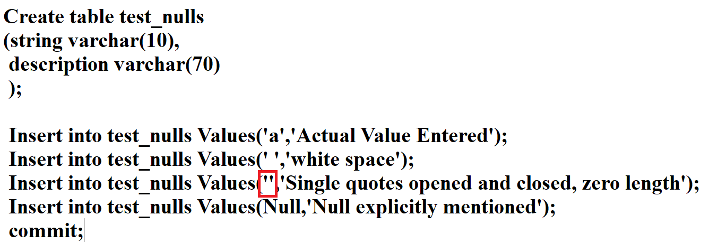

select * from test_nulls;

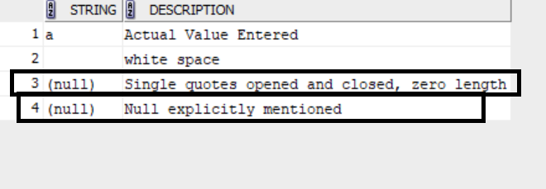

select * from test_nulls
where string is null; --?????

select * from test_nulls
where string is not null; --?????

Pattern Matching Operator LIKE

To replace any character and any number of characters use %

To display all the records where name starts with S

select * from emp
where ename like 'S%'

To replace particular number of characters use _ (Underscore)

To display records where there are exactly 3 characters before 01

select * from pcodes
where code like '___01';

To display the records where the 3rd character is %

select * from pcodes1
where code like 'AB\%Q1' ESCAPE '\';

